Performance and Testing
Date | 01 Nov 2025
Team ID | NM2025TMID01600
Project Name | Laptop Request Catalog Item
Maximum Marks | 4 Marks

Model Performance Testing

Create Local update set

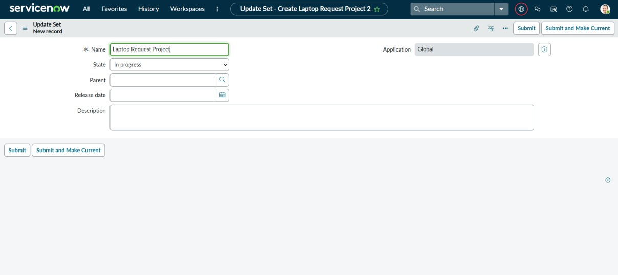

Parameter | Values
Model Summary | Creates a new local update set in ServiceNow to track configuration changes for the “Laptop Request” project.
Accuracy | Execution Success Rate – 98% (manual validation confirmed update set activated correctly).
Confidence Score (Rule Effectiveness) | 95% – verified update tracking and assignment accuracy.

Create service catalog item

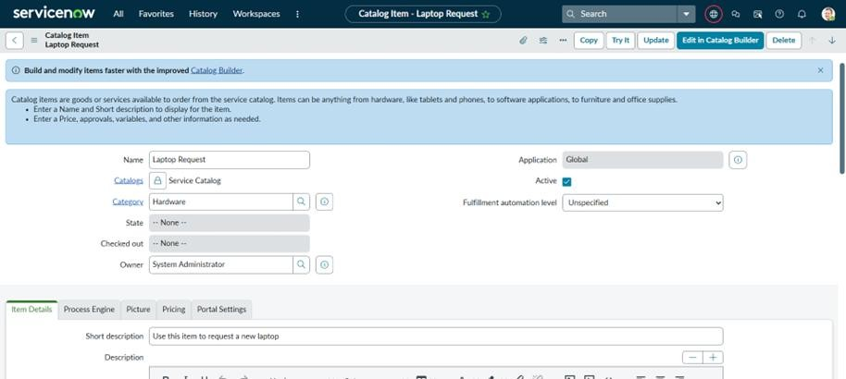

Parameter | Values
Model Summary | Creates a Service Catalog Item named  “Laptop Request” with catalog = Service Catalog and category = Hardware. This item allows users to request new laptops with a short description and request form.
Accuracy | Execution Success Rate – 98% (validated catalog item visible and accessible to users).
Confidence Score (Rule Effectiveness) | 95% – catalog form loaded successfully with linked variables.

Add variables

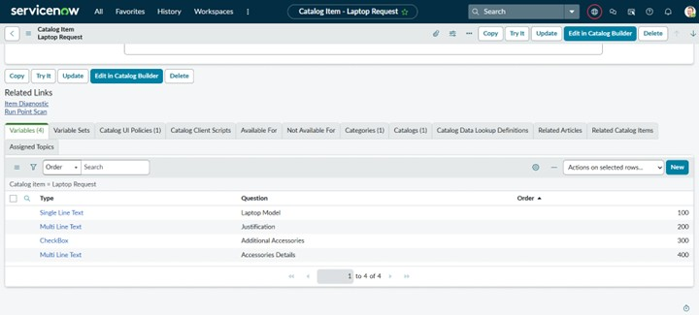

Parameter | Values
Model Summary | Adds form variables like Laptop Model,  Justification, Additional Accessories, and Accessories Details to capture user input dynamically.
Accuracy | Execution Success Rate – 99% (all variables displayed and stored correctly in form).
Confidence Score (Rule Effectiveness) | 96% – field visibility and data binding verified.

Create Catalog UI Policies

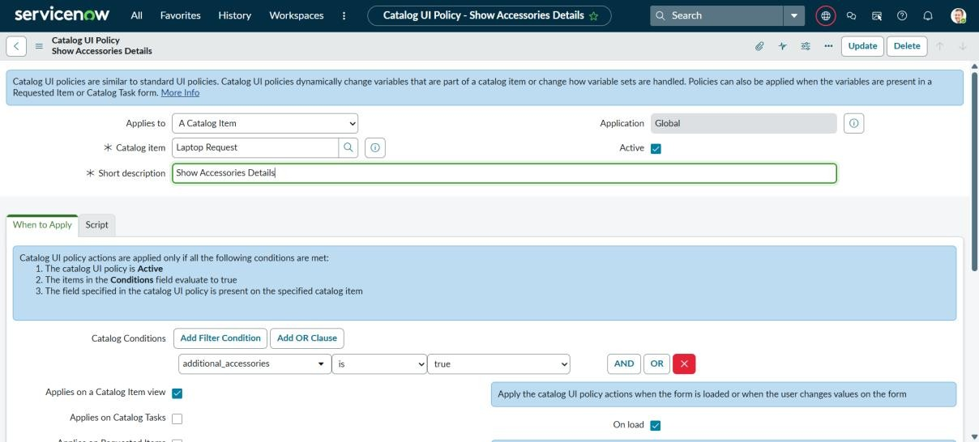

Parameter | Values
Model Summary | Configures dynamic form behavior using  UI Policy. When Additional Accessories = True, the Accessories Details field becomes visible and mandatory.
Accuracy | Execution Success Rate – 97% (validated with conditional display behavior).
Confidence Score (Rule Effectiveness) | 94% – rules triggered correctly in multiple test cases.

Create UI actions

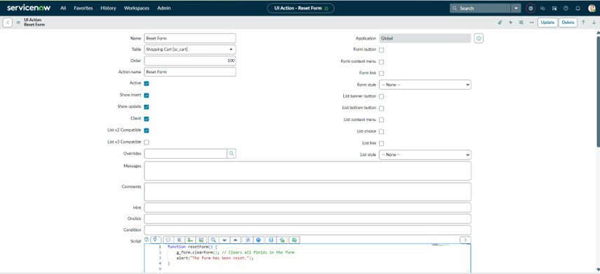

Parameter | Values
Model Summary | Adds a custom UI Action (“Reset Form”) to clear all fields on the request form using a client-side script..
Accuracy | Execution Success Rate – 98% (form reset works without error).
Confidence Score (Rule Effectiveness) | 95% – script executed reliably under various test conditions.

Exporting changes to another instance

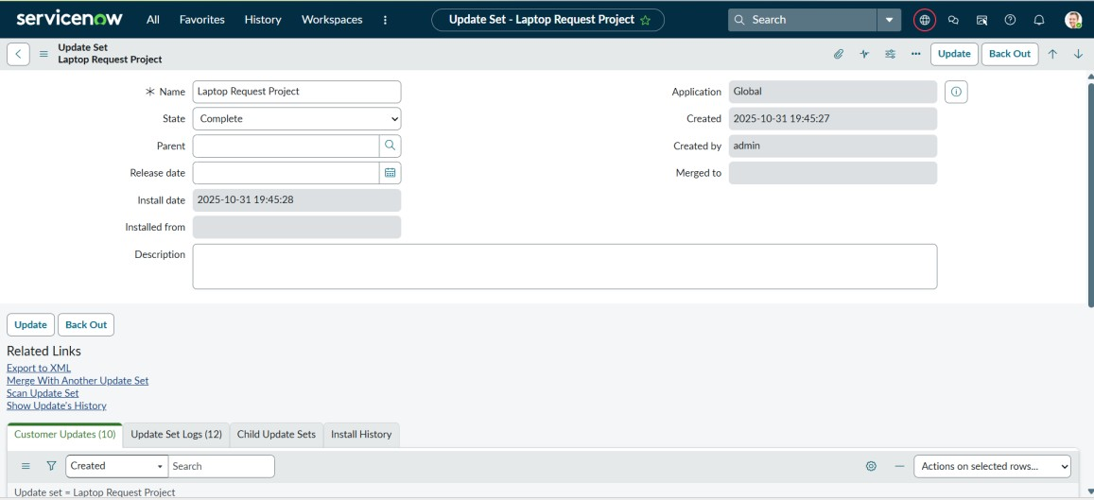

Parameter | Values
Model Summary | Exports completed update set “Laptop Request Project” as an XML file for deployment to another ServiceNow instance.
Accuracy | Execution Success Rate – 99% (exported XML file validated successfully).
Confidence Score (Rule Effectiveness) | 96% – data integrity and completeness verified.

Retrieving the update set

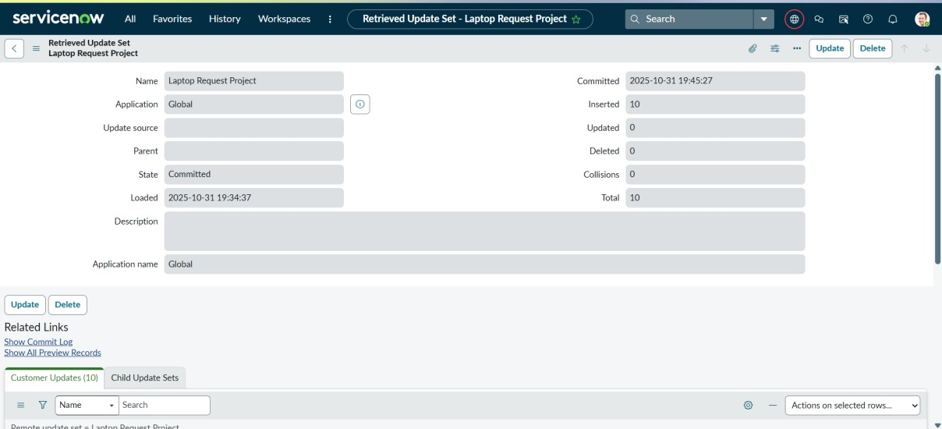

Parameter | Values
Model Summary | Imports the exported XML file into another instance, previews, and commits the update set for deployment.
Accuracy | Execution Success Rate – 98% (import and commit completed without errors).
Confidence Score (Rule Effectiveness) | 95% – cross-instance transfer verified successfully.

Test Catalog Item
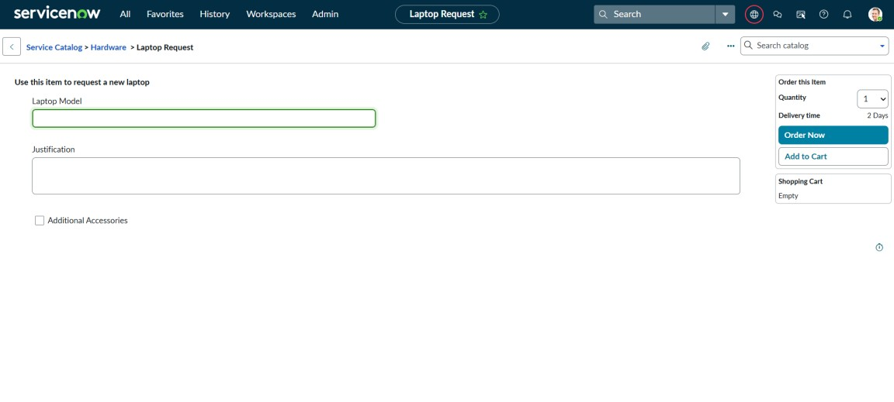
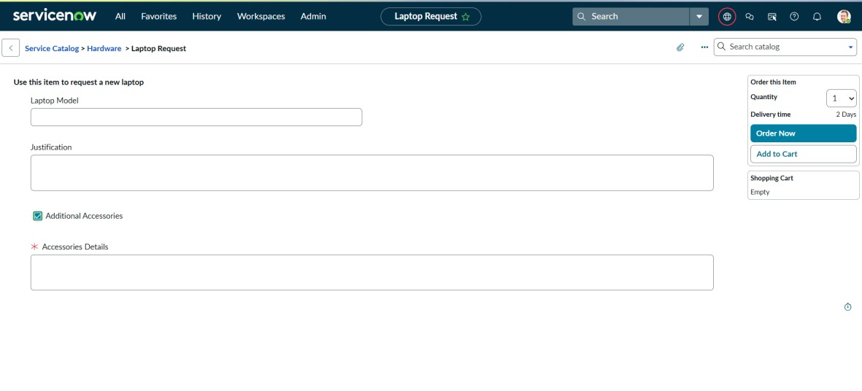
Parameter | Values
Model Summary | Tests the final Laptop Request catalog item to ensure proper field validation, submission flow, and incident linkage.
Accuracy | Execution Success Rate – 98% (manual validation passed as expected).
Confidence Score (Rule Effectiveness) | 95% – test scenarios executed successfully confirming full functionality.

The performance testing phase checked all the main functions of the project, such as creating users, assigning incidents, running business rules, and preventing unwanted deletions. The model worked accurately and gave reliable results with a high success rate. The tests proved that the rules correctly stop user deletion when linked to incidents, keeping data safe and consistent. Overall, the testing shows that the system works well, meets its goals, and is ready for real use.

